Sugarcane Trash as Biomass Resource
By Salman Zafar | February 23, 2015 - 8:25 am | Agricultural Residues, Biomass Energy, Cogeneration
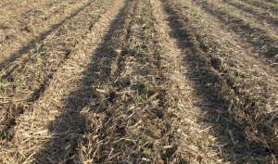Sugarcane trash (or cane trash) is an excellent biomass resource in sugar-producing countries worldwide. The amount of cane trash produced depends on the plant variety, age of the crop at harvest and soil and weather conditions. Typically it represents about 15% of the total above ground biomass at harvest which is equivalent to about 10-15 tons per hectare of dry matter. During the harvesting operation around 70-80% of the trash is left in the field with 20-30% taken to the mill together with the sugarcane stalks as extraneous matter. Cane trash’s calorific value is similar to that of bagasse but has an advantage of having lower moisture content, and hence dries more quickly. Nowadays only a small quantity of this biomass is used as fuel, mixed with bagasse or by itself, at the sugar mill. The rest is burned in the vicinity of the dry cleaning installation, creating a pollution problem in sugar-producing nations.
Cane trash and bagasse are produced during the harvesting and milling process of sugarcane which normally lasts between 6 to 7 months. Cane trash can potentially be converted into heat and electrical energy. However, most of the trash is burned in the field due to its bulky nature and high cost incurred in collection and transportation. Cane trash could be used as an off-season fuel for year-round power generation at sugar mills. There is also a high demand for biomass as a boiler fuel during the sugar-milling season. Sugarcane trash can also converted in biomass pellets and used in dedicated biomass power stations or co-fired with coal in power plants and cement kilns.
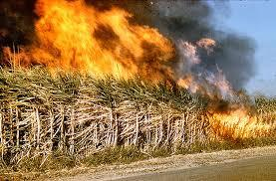
Burning of cane trash creates pollution in sugar-producing countries
Currently, a significant percentage of energy used for boilers in sugarcane processing is provided by imported bunker oil. Overall, the economic, environmental, and social implications of utilizing cane trash in the final crop year as a substitute for bunker oil appears promising. It represents an opportunity for developing biomass energy use in the Sugarcane industry as well as for industries / communities in the vicinity. Positive socio-economic impacts include the provision of large-scale rural employment and the minimization of oil imports. It can also develop the expertise necessary to create a reliable biomass supply for year-round power generation.

Recovery of Cane Trash
Recovery of cane trash implies a change from traditional harvesting methods; which normally consists of destroying the trash by setting huge areas of sugarcane fields ablaze prior to the harvest. There are a number of major technical and economic issues that need to be overcome to utilize cane trash as a renewable energy resource. For example, its recovery from the field and transportation to the mill, are major issues. Alternatives include the current situation where the cane is separated from the trash by the harvester and the two are transported to the mill separately, to the harvesting of the whole crop with separation of the cane and the trash carried out at the mill. Where the trash is collected from the field it maybe baled incurring a range of costs associated with bale handling, transportation and storage. Baling also leaves about 10-20% (1-2 tons per hectare) of the recoverable trash in the field.
A second alternative is for the cane trash to be shredded and collected separately from the cane during the harvesting process. The development of such a harvester-mounted cane trash shredder and collection system has been achieved but the economics of this approach require evaluation. A third alternative is to harvest the sugarcane crop completely which would require an adequate collection, transport and storage system in addition to a mill based cleaning plant to separate the cane from the trash .
A widespread method for cane trash recovery is to cut the cane, chop into pieces and then it is blown in two stages in the harvester to remove the trash. The amount of trash that goes along with the cane is a function of the cleaning efficiency of the harvester. The blowers are adjusted to get adequate cleaning with a bearable cane loss.
On the average 68 % of the trash is blown out of the harvester, and stays on the ground, and 32 % is taken to the mill together with the cane as extraneous matter. The technique used to recover the trash staying on the ground is baling. Several baling machines have been tested with small, large, round and square bales. Cane trash can be considered as a viable fuel supplementary to bagasse to permit year-round power generation in sugar mills.
Thus, recovery of cane trash in developing nations of Asia, Africa and Latin America implies a change from traditional harvesting methods, which normally consists of destroying the trash by setting huge areas of cane fields ablaze prior to the harvest. To recover the trash, a new so-called “green mechanical harvesting” scheme will have to be introduced. By recovering the trash in this manner, the production of local air pollutants, as well as greenhouse gases contributing to adverse climatic change, from the fires are avoided and cane trash could be used as a means of regional sustainable development.

Cane Trash Recovery in Cuba
The sugarcane harvesting system in Cuba is unique among cane-producing countries in two important respects. First, an estimated 70 % of the sugarcane crop is harvested by machine without prior burning, which is far higher than for any other country. The second unique feature of Cuban harvesting practice is the long-standing commercial use of “dry cleaning stations” to remove trash from the cane stalks before the stalks are transported to the crushing mills.
Cuba has over 900 cleaning stations to serve its 156 sugar mills. The cleaning stations are generally not adjacent to the mills, but are connected to mills by a low-cost cane delivery system – a dedicated rail network with more than 7000 km of track. The cleaning stations take in green machine-cut or manually cut cane. Trash is removed from the stalk and blown out into a storage area. The stalks travel along a conveyor to waiting rail cars. The predominant practice today is to incinerate the trash at the cleaning station to reduce the “waste” volume.

Cogeneration of Bagasse
By Salman Zafar | October 8, 2013 - 8:32 am | Agricultural Residues, Biomass Energy, Cogeneration
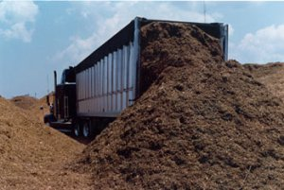Cogeneration of bagasse is one of the most attractive and successful energy projects that have already been demonstrated in many sugarcane producing countries such as Mauritius, Reunion Island, India and Brazil. Combined heat and power from sugarcane in the form of power generation offers renewable energy options that promote sustainable development, take advantage of domestic resources, increase profitability and competitiveness in the industry, and cost-effectively address climate mitigation and other environmental goals.
According to World Alliance for Decentralized Energy (WADE) report on Bagasse Cogeneration, bagasse-based cogeneration could deliver up to 25% of current power demand requirements in the world’s main cane producing countries. The overall potential share in the world’s major developing country producers exceeds 7%. There is abundant opportunity for the wider use of bagasse-based cogeneration in sugarcane-producing countries. It is especially great in the world’s main cane producing countries like Brazil, India, Thailand, Pakistan, Mexico, Cuba, Colombia, Philippines and Vietnam. Yet this potential remains by and large unexploited.
Using bagasse to generate power represents an opportunity to generate significant revenue through the sale of electricity and carbon credits. Additionally, cogeneration of heat and power allows sugar producers to meet their internal energy requirements and drastically reduce their operational costs, in many cases by as much as 25%. Burning bagasse also removes a waste product through its use as a feedstock for the electrical generators and steam turbines.
Most sugarcane mills around the globe have achieved energy self-sufficiency for the manufacture of raw sugar and can also generate a small amount of exportable electricity. However, using traditional equipment such as low-pressure boilers and counter-pressure turbo alternators, the level and reliability of electricity production is not sufficient to change the energy balance and attract interest for export to the electric power grid.
On the other hand, revamping the boiler house of sugar mills with high pressure boilers and condensing extraction steam turbine can substantially increase the level of exportable electricity. This experience has been witnessed in Mauritius, where, following major changes in the processing configurations, the exportable electricity from its sugar factory increased from around 30-40 kWh to around 100–140 kWh per ton cane crushed. In Brazil, the world’s largest cane producer, most of the sugar mills are upgrading their boiler configurations to 42 bars or even higher pressure of up to 67 bars.

Technology Options
The prime technology for sugar mill cogeneration is the conventional steam-Rankine cycle design for conversion of fuel into electricity. A combination of stored and fresh bagasse is usually fed to a specially designed furnace to generate steam in a boiler at typical pressures and temperatures of usually more than 40 bars and 440°C respectively. The high pressure steam is then expanded either in a back pressure or single extraction back pressure or single extraction condensing or double extraction cum condensing type turbo generator operating at similar inlet steam conditions.
Due to high pressure and temperature, as well as extraction and condensing modes of the turbine, higher quantum of power gets generated in the turbine–generator set, over and above the power required for sugar process, other by-products, and cogeneration plant auxiliaries. The excess power generated in the turbine generator set is then stepped up to extra high voltage of 66/110/220 kV, depending on the nearby substation configuration and fed into the nearby utility grid. As the sugar industry operates seasonally, the boilers are normally designed for multi-fuel operations, so as to utilize mill bagasse, procured Bagasse/biomass, coal and fossil fuel, so as to ensure year round operation of the power plant for export to the grid.

Latest Trends
Modern power plants use higher pressures, up to 87 bars or more. The higher pressure normally generates more power with the same quantity of Bagasse or biomass fuel. Thus, a higher pressure and temperature configuration is a key in increasing exportable surplus electricity.
In general, 67 bars pressure and 495°C temperature configurations for sugar mill cogeneration plants are well-established in many sugar mills in India. Extra high pressure at 87 bars and 510°C, configuration comparable to those in Mauritius, is the current trend and there are about several projects commissioned and operating in India and Brazil. The average increase of power export from 40 bars to 60 bars to 80 bars stages is usually in the range of 7-10%.
A promising alternative to steam turbines are gas turbines fuelled by gas produced by thermochemical conversion of biomass. The exhaust is used to raise steam in heat recovery systems used in any of the following ways: heating process needs in a cogeneration system, for injecting back into gas turbine to raise power output and efficiency in a steam-injected gas turbine cycle (STIG) or expanding through a steam turbine to boost power output and efficiency in a gas turbine/steam turbine combined cycle (GTCC). Gas turbines, unlike steam turbines, are characterized by lower unit capital costs at modest scale, and the most efficient cycles are considerably more efficient than comparably sized steam turbines.

Biomass Resources from Sugar Industry
By Salman Zafar | July 16, 2014 - 6:52 pm | Agricultural Residues, Biomass Energy
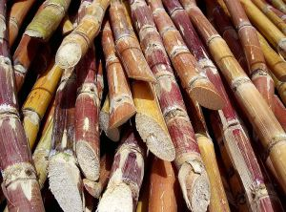Sugarcane is one of the most promising agricultural sources of biomass energy in the world. It is the most appropriate agricultural energy crop in most sugarcane producing countries due to its resistance to cyclonic winds, drought, pests and diseases, and its geographically widespread cultivation. Due to its high energy-to-volume ratio, it is considered one of nature’s most effective storage devices for solar energy and the most economically significant energy crop. The climatic and physiological factors that limit its cultivation to tropical and sub-tropical regions have resulted in its concentration in developing countries, and this, in turn, gives these countries a particular role in the world’s transition to sustainable use of natural resources.
According to the International Sugar Organization (ISO), Sugarcane is a highly efficient converter of solar energy, and has the highest energy-to-volume ratio among energy crops. Indeed, it gives the highest annual yield of biomass of all species. Roughly, 1 ton of Sugarcane biomass-based on Bagasse, foliage and ethanol output – has an energy content equivalent to one barrel of crude oil. Sugarcane produces mainly two types of biomass, Cane Trash and Bagasse. Cane Trash is the field residue remaining after harvesting the Cane stalk and Bagasse is the milling by-product which remains after extracting sugar from the stalk. The potential energy value of these residues has traditionally been ignored by policy-makers and masses in developing countries. However, with rising fossil fuel prices and dwindling firewood supplies, this material is increasingly viewed as a valuable renewable energy resource.
Sugar mills have been using Bagasse to generate steam and electricity for internal plant requirements while Cane Trash remains underutilized to a great extent. Cane Trash and Bagasse are produced during the harvesting and milling process of Sugarcane which normally lasts 6 to 7 months.
Around the world, a portion of the Cane Trash is collected for sale to feed mills, while freshly cut green tops are sometimes collected for farm animals. In most cases, however, the residues are burned or left in the fields to decompose. Cane Trash, consisting of Sugarcane tops and leaves can potentially be converted into around 1kWh/kg, but is mostly burned in the field due to its bulkiness and its related high cost for collection/transportation.
On the other hand, Bagasse has been traditionally used as a fuel in the Sugar mill itself, to produce steam for the process and electricity for its own use. In general, for every ton of Sugarcane processed in the mill, around 190 kg Bagasse is produced. Low pressure boilers and low efficiency steam turbines are commonly used in developing countries. It would be a good business proposition to upgrade the present cogeneration systems to highly efficient, high pressure systems with higher capacities to ensure utilization of surplus Bagasse.

Energy Potential of Bagasse
By Salman Zafar | December 22, 2014 - 12:08 pm | Agricultural Residues, Biomass Energy, Cogeneration
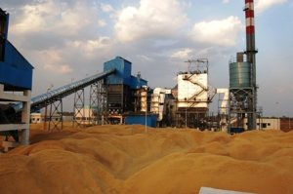Sugarcane is one of the most promising agricultural sources of biomass energy in the world. Sugarcane produces mainly two types of biomass, Cane Trash and Bagasse. Cane Trash is the field residue remaining after harvesting the Cane stalk while bagasse is the fibrous residue left over after milling of the Cane, with 45-50% moisture content and consisting of a mixture of hard fibre, with soft and smooth parenchymatous (pith) tissue with high hygroscopic property. Bagasse contains mainly cellulose, hemi cellulose, pentosans, lignin, Sugars, wax, and minerals. The quantity obtained varies from 22 to 36% on Cane and is mainly due to the fibre portion in Cane and the cleanliness of Cane supplied, which, in turn, depends on harvesting practices.
The composition of Bagasse depends on the variety and maturity of Sugarcane as well as harvesting methods applied and efficiency of the Sugar processing. Bagasse is usually combusted in furnaces to produce steam for power generation. Bagasse is also emerging as an attractive feedstock for bioethanol production. It is also utilized as the raw material for production of paper and as feedstock for cattle. The value of Bagasse as a fuel depends largely on its calorific value, which in turn is affected by its composition, especially with respect to its water content and to the calorific value of the Sugarcane crop, which depends mainly on its sucrose content.
Moisture contents is the main determinant of calorific value i.e. the lower the moisture content, the higher the calorific value. A good milling process will result in low moisture of 45% whereas 52% moisture would indicate poor milling efficiency. Most mills produce Bagasse of 48% moisture content, and most boilers are designed to burn Bagasse at around 50% moisture. Bagasse also contains approximately equal proportion of fibre (cellulose), the components of which are carbon, hydrogen and oxygen, some sucrose (1-2 %), and ash originating from extraneous matter. Extraneous matter content is higher with mechanical harvesting and subsequently results in lower calorific value.
For every 100 tons of Sugarcane crushed, a Sugar factory produces nearly 30 tons of wet Bagasse. Bagasse is often used as a primary fuel source for Sugar mills; when burned in quantity, it produces sufficient heat and electrical energy to supply all the needs of a typical Sugar mill, with energy to spare. The resulting CO₂ emissions are equal to the amount of CO₂ that the Sugarcane plant absorbed from the atmosphere during its growing phase, which makes the process of cogeneration greenhouse gas-neutral.
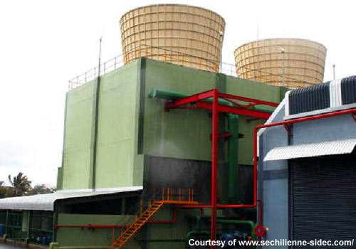
35MW Bagasse and Coal CHP Plant in Mauritius
Cogeneration of Bagasse is one of the most attractive and successful energy projects that have already been demonstrated in many Sugarcane producing countries such as Mauritius, Reunion Island, India and Brazil. Combined heat and power from Sugarcane in the form of power generation offers renewable energy options that promote sustainable development, take advantage of domestic resources, increase profitability and competitiveness in the industry, and cost-effectively address climate mitigation and other environmental goals.

Overview of Biomass Energy Systems
By Salman Zafar | February 20, 2015 - 7:01 pm | Biomass Energy, Renewable Energy
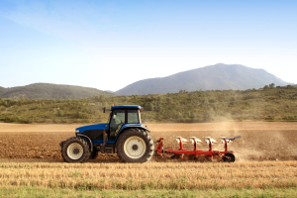Biomass is a versatile energy source that can be used for production of heat, power, transport fuels and biomaterials, apart from making a significant contribution to climate change mitigation. Currently, biomass-driven combined heat and power, co-firing, and combustion plants provide reliable, efficient, and clean power and heat. Feedstock for biomass energy plants can include residues from agriculture, forestry, wood processing, and food processing industries, municipal solid wastes, industrial wastes and biomass produced from degraded and marginal lands.
The terms biomass energy, bioenergy and biofuels cover any energy products derived from plant or animal or organic material. The increasing interest in biomass energy and biofuels has been the result of the following associated benefits:
- Potential to reduce GHG emissions.
- Energy security benefits.
- Substitution for diminishing global oil supplies.
- Potential impacts on waste management strategy.
- Capacity to convert a wide variety of wastes into clean energy.
- Technological advancement in thermal and biochemical processes for waste-to-energy transformation.
Biomass can play the pivotal role in production of carbon-neutral fuels of high quality as well as providing feedstocks for various industries. This is a unique property of biomass compared to other renewable energies and which makes biomass a prime alternative to the use of fossil fuels. Performance of biomass-based systems for heat and power generation has been already proved in many situations on commercial as well as domestic scales.
Biomass energy systems have the potential to address many environmental issues, especially global warming and greenhouse gases emissions, and foster sustainable development among poor communities. Biomass fuel sources are readily available in rural and urban areas of all countries. Biomass-based industries can provide appreciable employment opportunities and promote biomass re-growth through sustainable land management practices.
The negative aspects of traditional biomass utilization in developing countries can be mitigated by promotion of modern waste-to-energy technologies which provide solid, liquid and gaseous fuels as well as electricity as shown. Biomass wastes can be transformed into clean and efficient energy by biochemical as well as thermochemical technologies.
The most common technique for producing both heat and electrical energy from biomass wastes is direct combustion. Thermal efficiencies as high as 80 – 90% can be achieved by advanced gasification technology with greatly reduced atmospheric emissions. Combined heat and power (CHP) systems, ranging from small-scale technology to large grid-connected facilities, provide significantly higher efficiencies than systems that only generate electricity. Biochemical processes, like anaerobic digestion and sanitary landfills, can also produce clean energy in the form of biogas and producer gas which can be converted to power and heat using a gas engine.
In addition, biomass wastes can also yield liquid fuels, such as cellulosic ethanol, which can be used to replace petroleum-based fuels. Cellulosic ethanol can be produced from grasses, wood chips and agricultural residues by biochemical route using heat, pressure, chemicals and enzymes to unlock the sugars in cellulosic biomass. Algal biomass is also emerging as a good source of energy because it can serve as natural source of oil, which conventional refineries can transform into jet fuel or diesel fuel.

An Introduction to Biomass Energy
By Salman Zafar | February 26, 2015 - 7:39 pm | Biomass Energy
Biomass is the material derived from plants that use sunlight to grow which include plant and animal material such as wood from forests, material left over from agricultural and forestry processes, and organic industrial, human and animal wastes. Biomass comes from a variety of sources which include:
- Wood from natural forests and woodlands
- Forestry plantations
- Forestry residues
- Agricultural residues such as straw, stover, cane trash and green agricultural wastes
- Agro-industrial wastes, such as sugarcane bagasse and rice husk
- Animal wastes
- Industrial wastes, such as black liquor from paper manufacturing
- Sewage
- Municipal solid wastes (MSW)
- Food processing wastes
In nature, if biomass is left lying around on the ground it will break down over a long period of time, releasing carbon dioxide and its store of energy slowly. By burning biomass its store of energy is released quickly and often in a useful way. So converting biomass into useful energy imitates the natural processes but at a faster rate.
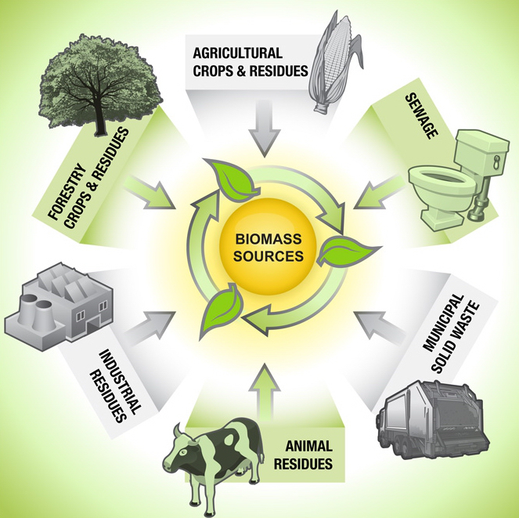
Biomass can be transformed into clean energy and/or fuels by a variety of technologies, ranging from conventional combustion process to emerging biofuels technology. Besides recovery of substantial energy, these technologies can lead to a substantial reduction in the overall waste quantities requiring final disposal, which can be better managed for safe disposal in a controlled manner while meeting the pollution control standards.
Biomass waste-to-energy conversion reduces greenhouse gas emissions in two ways. Heat and electrical energy is generated which reduces the dependence on power plants based on fossil fuels. The greenhouse gas emissions are significantly reduced by preventing methane emissions from landfills. Moreover, biomass energy plants are highly efficient in harnessing the untapped sources of energy from biomass resources.

Importance of Biomass Energy
By Salman Zafar | April 17, 2014 - 9:52 am | Biomass Energy, Renewable Energy
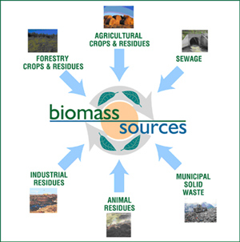
Biomass energy has rapidly become a vital part of the global renewable energy mix and account for an ever-growing share of electric capacity added worldwide. As per a recent UNEP report, total renewable power capacity worldwide exceeded 1,470 GW in 2012, up 8.5% from 2011. Renewable energy supplies around one-fifth of the final energy consumption worldwide, counting traditional biomass, large hydropower, and “new” renewables (small hydro, modern biomass, wind, solar, geothermal, and biofuels).
Traditional biomass, primarily for cooking and heating, represents about 13 percent and is growing slowly or even declining in some regions as biomass is used more efficiently or replaced by more modern energy forms. Some of the recent predictions suggest that biomass energy is likely to make up one third of the total world energy mix by 2050. Infact, biofuel provides around 3% of the world’s fuel for transport.
Biomass energy resources are readily available in rural and urban areas of all countries. Biomass-based industries can provide appreciable employment opportunities and promote biomass re-growth through sustainable land management practices. The negative aspects of traditional biomass utilization in developing countries can be mitigated by promotion of modern waste-to-energy technologies which provide solid, liquid and gaseous fuels as well as electricity. Biomass wastes encompass a wide array of materials derived from agricultural, agro-industrial, and timber residues, as well as municipal and industrial wastes.
The most common technique for producing both heat and electrical energy from biomass wastes is direct combustion. Thermal efficiencies as high as 80 – 90% can be achieved by advanced gasification technology with greatly reduced atmospheric emissions. Combined heat and power (CHP) systems, ranging from small-scale technology to large grid-connected facilities, provide significantly higher efficiencies than systems that only generate electricity. Biochemical processes, like anaerobic digestion and sanitary landfills, can also produce clean energy in the form of biogas and producer gas which can be converted to power and heat using a gas engine.

Advantages of Biomass Energy
Bioenergy systems offer significant possibilities for reducing greenhouse gas emissions due to their immense potential to replace fossil fuels in energy production. Biomass reduces emissions and enhances carbon sequestration since short-rotation crops or forests established on abandoned agricultural land accumulate carbon in the soil.
Bioenergy usually provides an irreversible mitigation effect by reducing carbon dioxide at source, but it may emit more carbon per unit of energy than fossil fuels unless biomass fuels are produced unsustainably. Biomass can play a major role in reducing the reliance on fossil fuels by making use of thermo-chemical conversion technologies. In addition, the increased utilization of biomass-based fuels will be instrumental in safeguarding the environment, generation of new job opportunities, sustainable development and health improvements in rural areas.
The development of efficient biomass handling technology, improvement of agro-forestry systems and establishment of small and large-scale biomass-based power plants can play a major role in rural development. Biomass energy could also aid in modernizing the agricultural economy.
When compared with wind and solar energy, biomass plants are able to provide crucial, reliable baseload generation. Biomass plants provide fuel diversity, which protects communities from volatile fossil fuels. Since biomass energy uses domestically-produced fuels, biomass power greatly reduces our dependence on foreign energy sources and increases national energy security.
A large amount of energy is expended in the cultivation and processing of crops like sugarcane, coconut, and rice which can met by utilizing energy-rich residues for electricity production. The integration of biomass-fueled gasifiers in coal-fired power stations would be advantageous in terms of improved flexibility in response to fluctuations in biomass availability and lower investment costs. The growth of the bioenergy industry can also be achieved by laying more stress on green power marketing.

Rationale for Biomass Supply Chain
By Setu Goyal | March 18, 2015 - 10:20 pm | Agricultural Residues, Biomass Energy
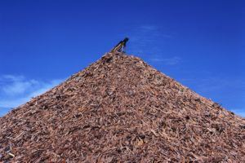Biomass resources have been in use for a variety of purposes since ages. The multiple uses of biomass includes usage as a livestock or for meeting domestic and industrial thermal requirements or for the generation of power to fulfill any electrical or mechanical needs. One of the major issues, however, associated with the use of any biomass resources is its supply chain management. The resource being bulky, voluminous and only seasonally available creates serious hurdles in the reliable supply of the feedstock, regardless of its application. The idea is thus to have something which plugs in this gap between the biomass resource availability and its demand.

The Problem
The supply chain management in any biomass based project is nothing less than a big management conundrum. The complexity deepens owing to the large number of stages which encompass the entire biomass value chain. It starts right from the resource harvesting and goes on to include the resource collection, processing, storage and eventually its transportation to the point of ultimate utilization.
Owing to the voluminous nature of the resource, its handling becomes a major issue since it requires bigger modes of logistics, employment of a larger number of work-force and a better storage infrastructure, as compared to any other fuel or feedstock. Not only this their lower energy density characteristic, makes it inevitable for the resource to be first processed and then utilized for power generation to make for better economics.
All these hassles associated with such resources, magnify the issue of their utilization when it comes to their supply chain. The seasonal availability of most of the biomass resources, alternative application options, weather considerations, geographical conditions and numerous other parameters make it difficult for the resource to be made consistently available throughout the year. This results in poor feedstock inputs at the utilization point which ends up generating energy in a highly erratic and unreliable manner.

The Solution
Although most of the problems discussed above, are issues inherently associated with the usage of biomass resources, they can be curtailed to a larger extent by strengthening the most important loophole in such projects – The Biomass Resource Supply Chain.
World over, major emphasis has been laid in researching upon the means to improve the efficiencies of such technologies. However, no significant due diligence has been carried out in fortifying the entire resource chain to assure such plants for a continuous resource supply.
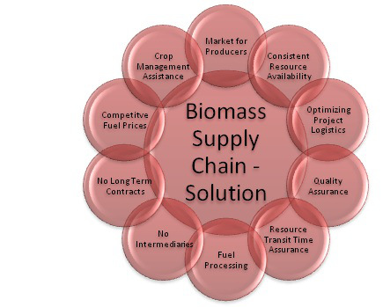
The usual solution to encounter such a problem is to have long term contracts with the resource providers to not only have an assured supply but also guard the project against unrealistic escalations in the fuel costs. Although, this solution has been found to be viable, it becomes difficult to sustain such contracts for longer duration since these resources are also susceptible to numerous externalities which could be in the form of any natural disaster, infection from pests or any other socio-political or geographical disturbances, which eventually lead to an increased burden on the producers.

http://www.canegrowers.com.au/page/Industry_Centre/Movie_Centre/Virtual_Bus_Tour/Virtual_Bus_Tour_Nutrient_Management_Compost/

